VITYARTHI PROJECT
REPORT

THE ASSIGNMENT ENTERED IN THIS REPORT HAVE BEEN SATISFACTORILY PERFORMED BY

Registration No : 25BCY10089
Name of Student : PRIYAL MAHESHWARI
Course Name : DIGITAL LITERACY
Course Code : CSE0001
School Name : SCAI
Slot : F21
Semester : WINTER 2025/26

Course Faculty Name : DR. KANNAN

Signature:

Project Index
Sr. No. | Topic | Date of submission | Signature of Faculty
1. | As the Student Digital Ambassador, you need to create a one-page visual resource that helps your batchmates understand what Digital Literacy means and why it matters. | 31/03/26

TASK 1

TITLE: Create a Digital Literacy Awareness Infographic

AIM/OBJECTIVE(s): As the Student Digital Ambassador, you need to create a one-page visual resource that helps your batchmates understand what Digital Literacy means and why it matters.

BRIEF DESCRIPTION:
This project focuses on creating a single infographic that explains the concept of digital literacy and highlights important aspects such as safe internet practices and email etiquette. The infographic presents digital literacy as the ability to use technology wisely, understand digital information, and apply critical thinking while evaluating online resources. It also emphasizes key safety practices like protecting privacy, using strong passwords, and being cautious of scams and phishing. Additionally, it includes essential email etiquette tips such as using clear subject lines, maintaining politeness, and checking grammar.
The tool used to design this infographic was a digital design platform known as Canva, which helped in organizing content visually. Various features like templates, icons, text formatting, color themes, and layout alignment were used to make the infographic attractive and easy to understand. The use of headings, bullet points, and visual hierarchy made the information more engaging.

RESULTS ACHIEVED:
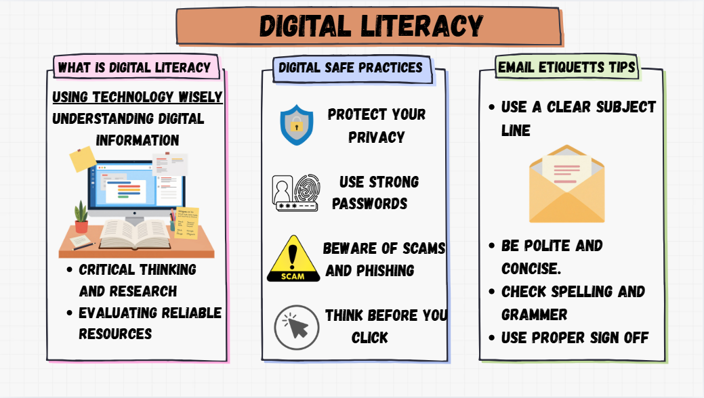

DIFFICULTY FACED BY STUDENT:
Some difficulties faced during the project included selecting the most relevant information to keep the infographic concise, arranging content in a visually appealing manner, and maintaining proper alignment and spacing. Choosing suitable colors and fonts that enhance readability was also a challenge.
Overall, this project helped in understanding both the importance of digital literacy and the skills required to present information effectively in a visual format.

SKILLS ACHIEVED:
Through this project, several skills were developed, including content summarization, visual communication, creativity, and basic design skills. It also improved understanding of digital safety and professional communication.

